Fin 470 Final Exam
Total – 30 Time – 1 hour
You are given the charge to find out the change in Minimum Capital Requirement for Bank ABC. They are a mix of both corporate and customer bank. Their major corporate accounts are spread out in two major clients, General Electric (A publicly listed electric company), Hansadox Capital (a private limited asset management company). When asked they provide you with the following data for General Electric and Hansadox capital:
General Electric:
Their Key Statistics are given below:
Trading Price | 30.17 USD
Beta: | 1.27
Avg Vol (3 month) Trading | 90,531,800
Shares Outstanding: | 10.11B
% Held by insiders | 0.05%
% Held by institutions | 56.60%
Annual Dividend Yeild | 3.02%
Payout Ratio | 178.37%

The balance sheet looks as follows:
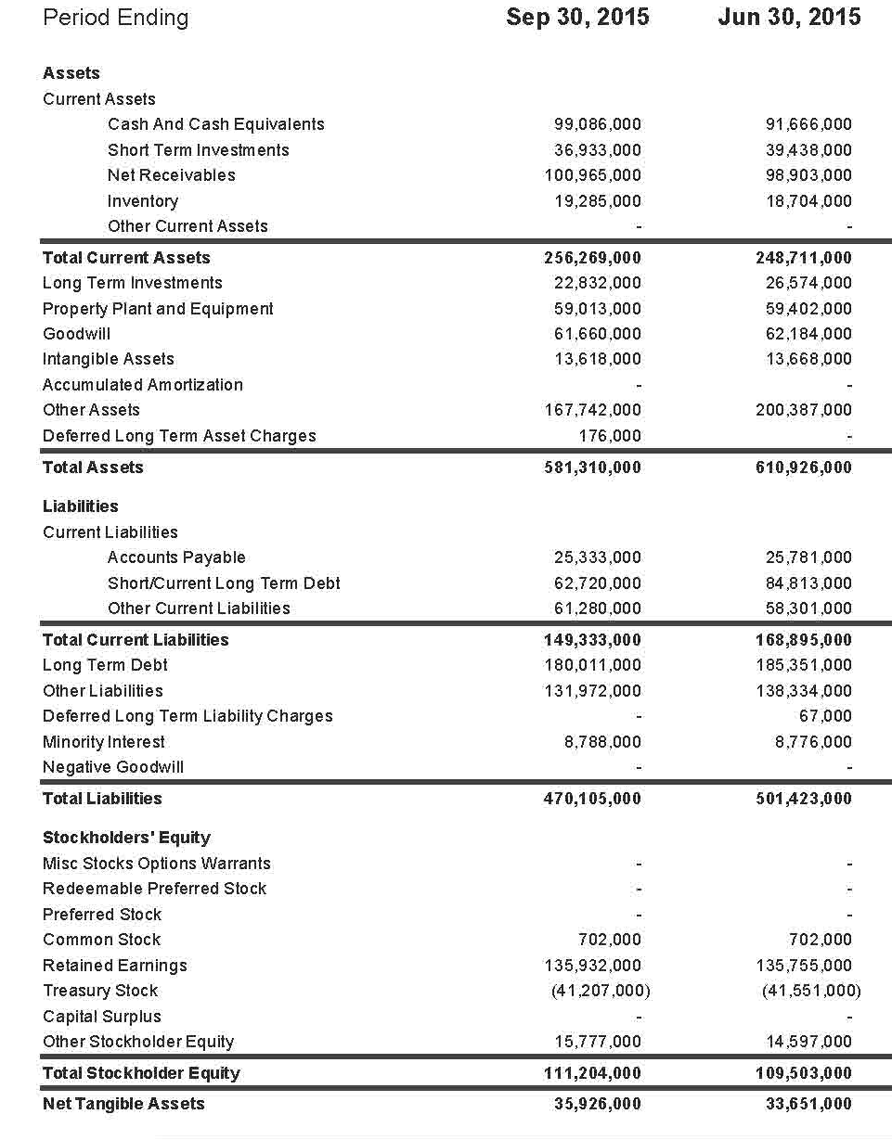

And the Income Statement Looks as Follows:
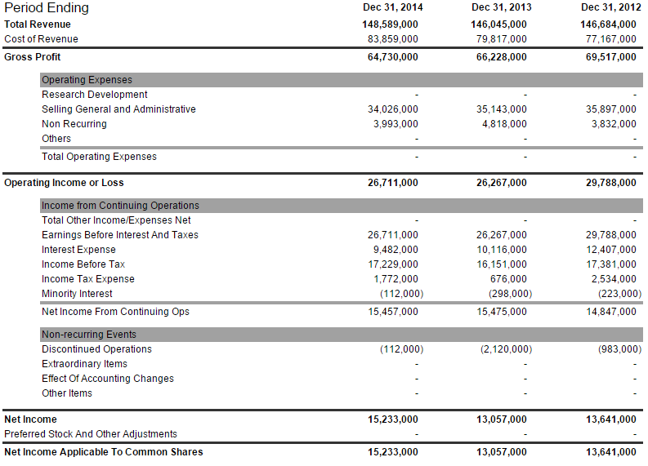
Hansadox Capital:
Their Key Statistics are given below:
Trading Price | 47.25 USD
Beta: | N/A
Avg Vol (3 month) Trading | N/A
Shares Outstanding: | 188.92M
% Held by insiders | 100%
% Held by institutions | N/A
Annual Dividend Yeild | N/A
Payout Ratio | N/A

Balance Sheet:
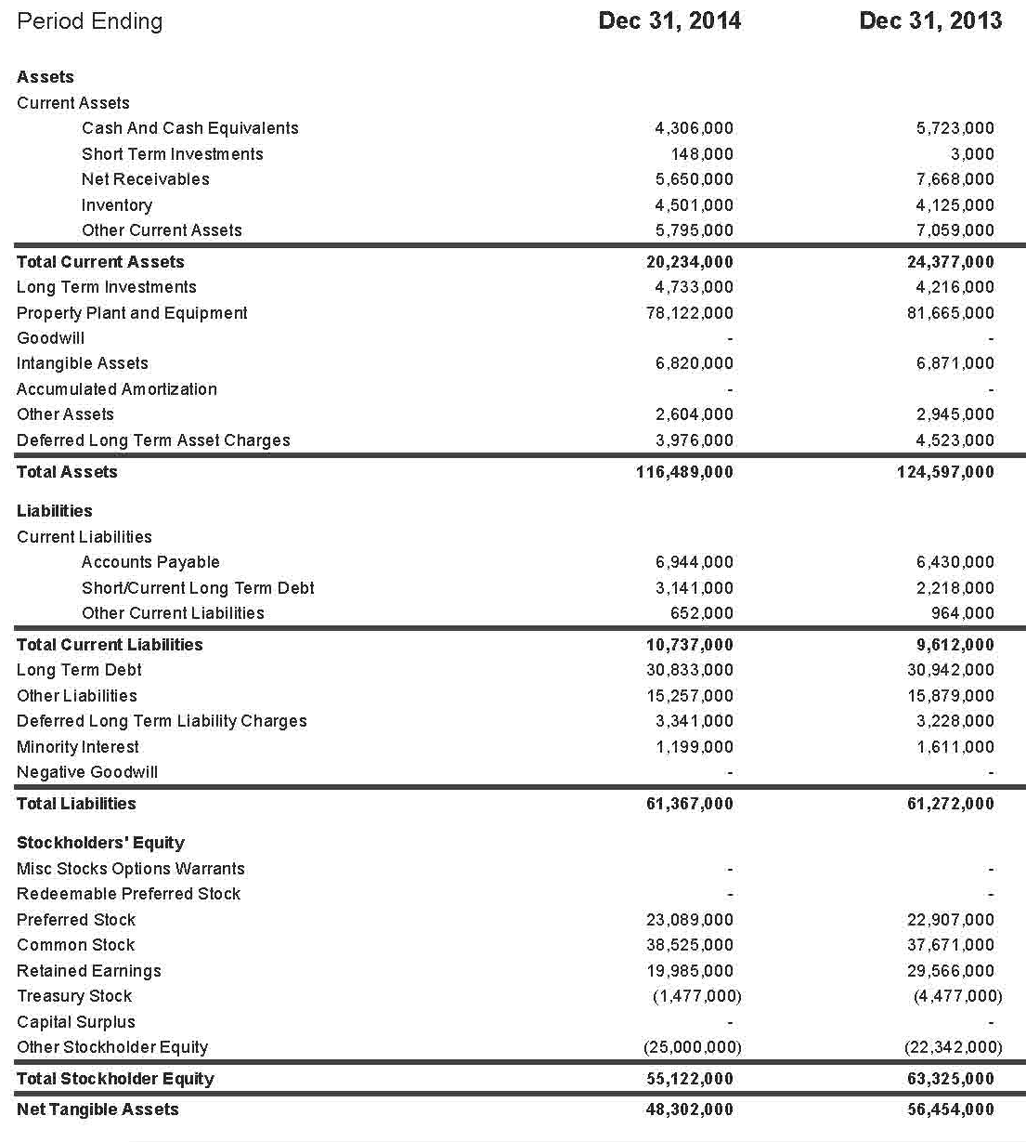

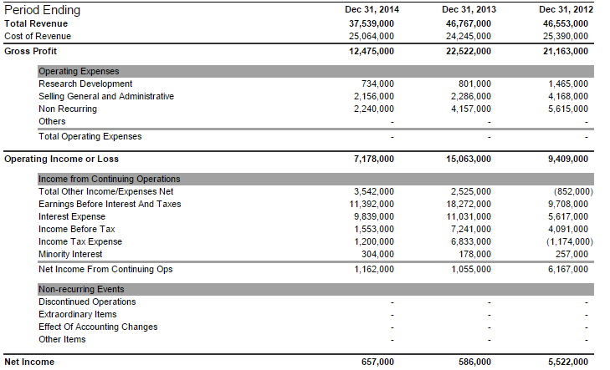
Income Statement:

Now, you collect information on the possible exposure to risk that the bank has for both these clients. For the General Electronic, your analysis shows that the gain distribution follows a normal distribution with a standard deviation of 18m, and a mean of 243m, for a period of 1 year. The exposure for Hansadox is a bit more complicated to calculate. Being an asset management company, it has its wealth being invested three major investments – a car company, an emerging market in Asia and a toiletries company. The correlation matrix of their returns are shown in the table below:
 | Car | Asia | Toiletries
Car | 1 | 0.89 | -0.97
Asia |  | 1 | 0.35
Toiletries |  |  | 1

For the car company investment, the loss distribution for 5 months is again a normal distribution with a variance of 670m and a mean of 510m. For both the Asian market and the Toiletries, the loss distributions are uniform. The Asian one ranges from a loss of -450m to 800m, and the Toiletries market one ranges from -100m to 500m.
Q1. Given these data, what is net change in minimum capital requirement needed by the Bank? (17 marks)
The bank has a policy of looking at the immediate past data and make some generic assumptions to check for the previous year’s performance of the company. Based on the performance, it checks whether the riskiness has changed drastically the period of one year. If let’s say the riskiness has remained constant, then the RWA is not changed. Even if the riskiness of the companies have decreased over one year, then the RWA is still not changed. But if there is an increase in riskiness over the year, the banks adds a certain percentage (called a riskiness haircut) with the RWA calculated amount and then calculates the minimum capital requirement.
Q2. Given this added information and the data provided on both the company’s financial statement over the last one year, does your answer for question 1 change? Explain briefly. (5)
One final thing is the customer banking segment. The customer borrowings in the market are always very risk, and the collaterals are never good enough to back up a defaulting customer.
Q3. If you are supposed to suggest a distribution to represent the summation of all the customer’s accounts, which distribution would you suggest? Why? (3)
Formulae Supplement
Altman’s Z Score:
1. Original Z-Score formula for public manufacturing companies:
Original Z-Score = 1.2X1 + 1.4X2 + 3.3X3 + 0.6X4 + 0.999X5
2. Model A Z-Score for private manufacturing companies: this model substitutes the book values of equity for the Market value in X4 compared to original model.
Model A Z-Score = 0.717X1 + 0.847X2 + 3.107X3 +0.420X4 +0.998X5
3. Model B Z-Score for private general companies: this model analyzed the characteristics and accuracy of a model without X4
Model B Z-Score = 6.56X1 + 3.26X2 +6.72X3 +1.05X5
X1 = working capital/total Assets. It measures the net liquid asset of a company relative to the total assets.
X2 = retained earnings/total Assets. It measures the financial leverage level of a company.
X3 = earnings before interests and taxes/total Assets. It measures productivity of a company’s total assets.
X4 = market value of equity/book value of total liabilities. It measures what portion of a company’s assets can decline in value before the liabilities exceed the assets.
X5 = sales/total Assets. It measures revenue generating ability of a company’s assets.

Z Score to Rating:
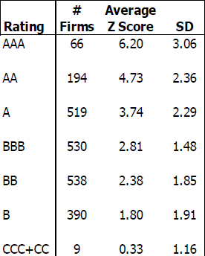

Rating to PD
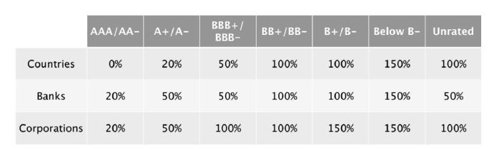

Investopedia Definitions:
Working Capital Table: Working Capital is a measure of both a company's efficiency and its short-term financial health. Working capital is calculated as: Working Capital = Current Assets - Current Liabilities.
Market Value of Equity: The total dollar market value of all of a company's outstanding shares. Market value of equity is calculated by multiplying the company's current stock price by its number of outstanding shares. A company's market value of equity is therefore always changing as these two input variables change.

