Guide to Download R, R Studio and Rcmdr

Installing R
Step 1
Go to the website:
https://cran.r-project.org/bin/windows/base/
You will see the following screen:
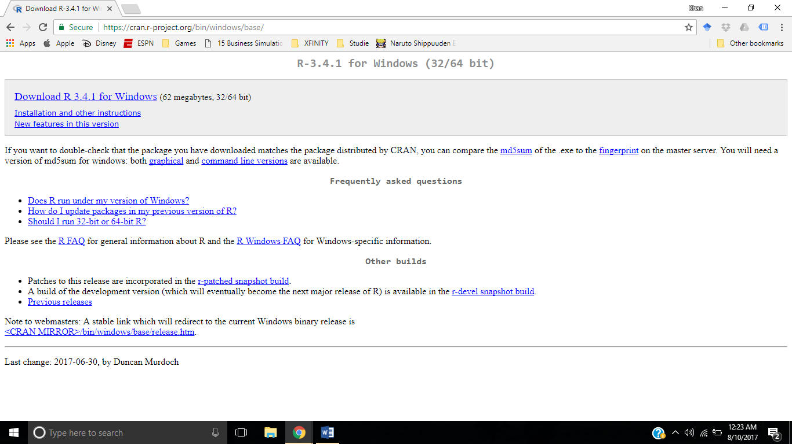

Step 2
Click on the download link highlighted in the above diagram. Or else, you can also directly use the following link if you are using a windows operating system:
https://cran.r-project.org/bin/windows/base/R-3.4.1-win.exe

Step 3
An installer will be downloaded, use the installer to install R:
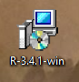
Clicking this icon twice will start the installer. Click on next on all the default options, and then the installation will start.

Installing R Studio

Step 1
Go to the R Studio Installation Website:
https://www.rstudio.com/products/rstudio/download/#download
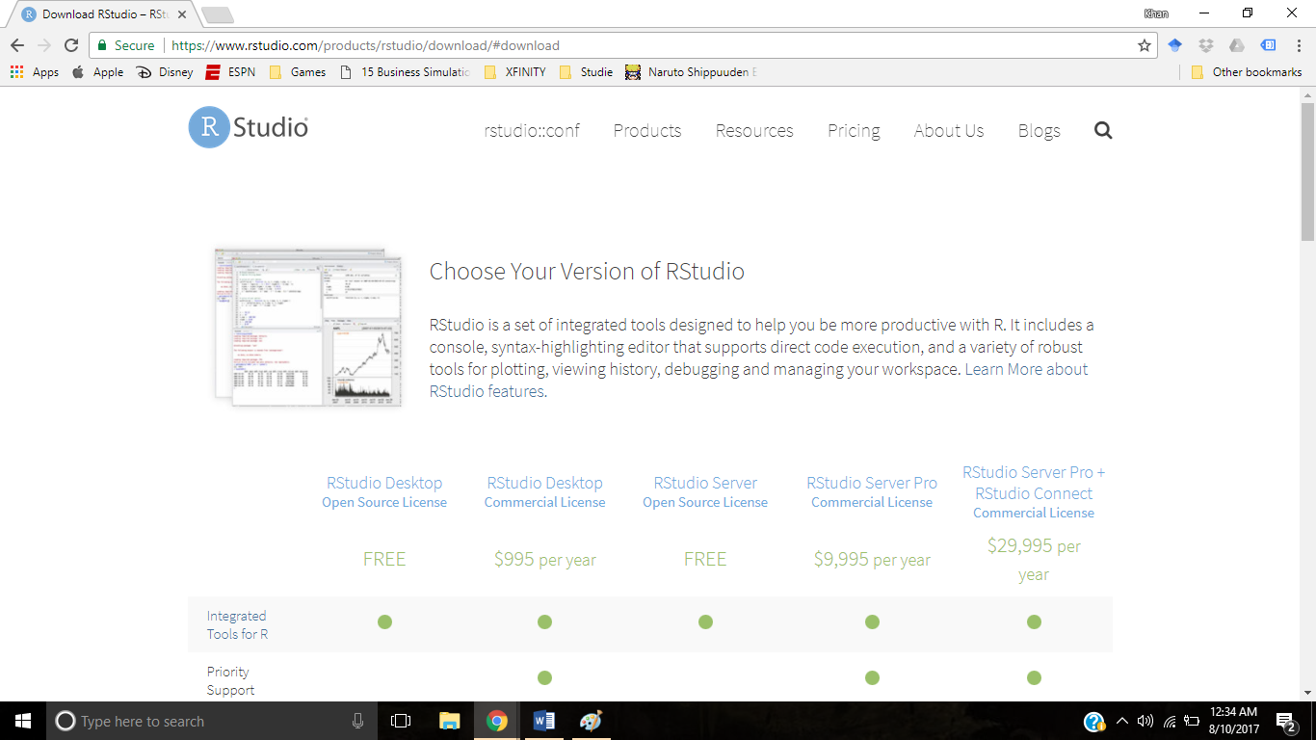

Step 2
Scroll down the webpage to see the following options:
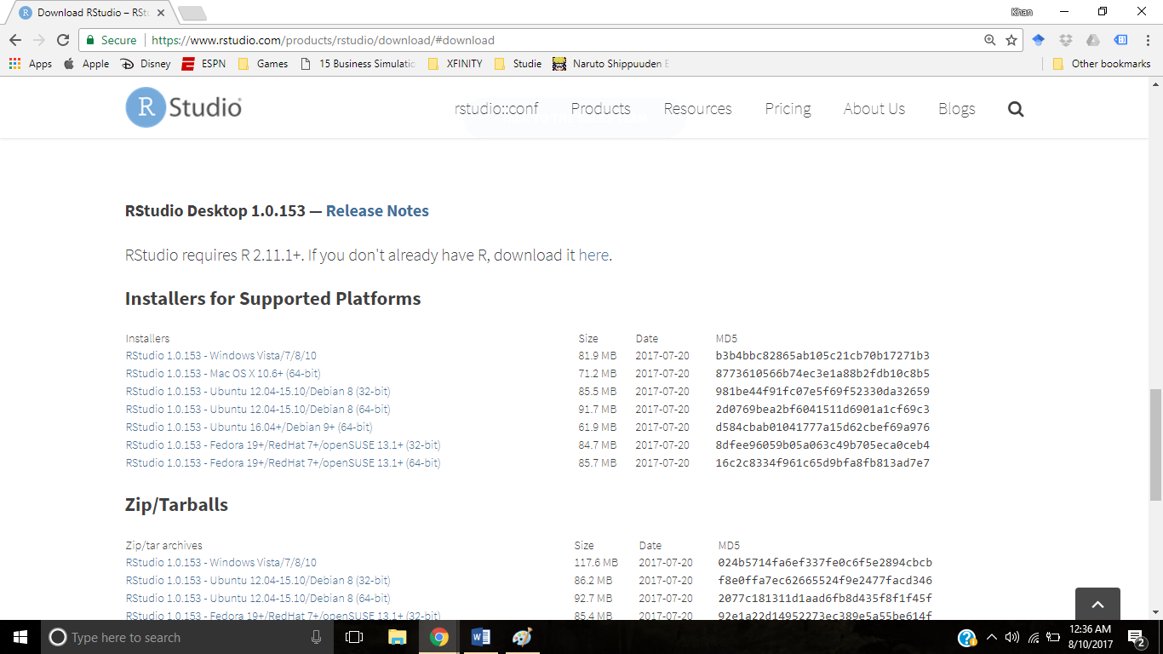

Step 3:
Based on the operating system you have, click on the link. For example, if your operating system is Windows Vista or Windows 7 or 8 or 10, just click on the first link:
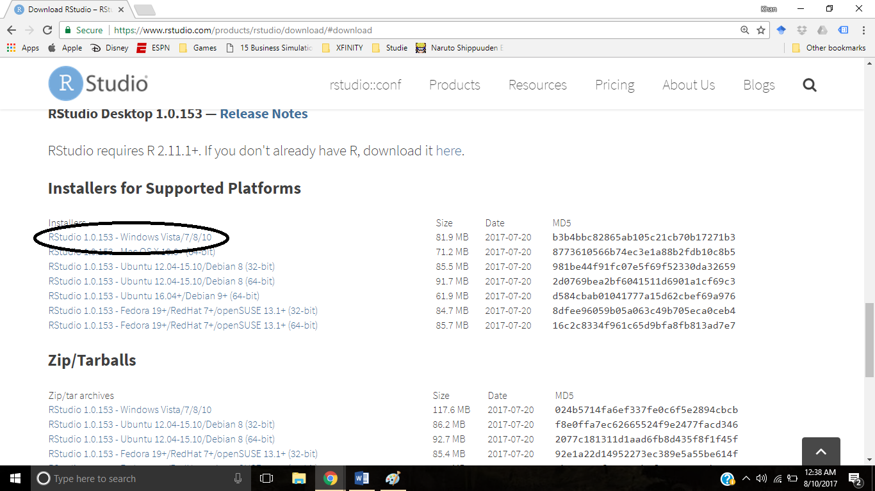
Also if you are using Windows Vista or Windows 7 or 8 or 10 then there is a shortcut link:
https://download1.rstudio.org/RStudio-1.0.153.exe

Step 4
Install R Studio from the Installer that you downloaded in step 3. The installer would look like this in your downloaded folder:
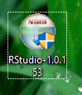
Double clicking this will start the installation for R Studio.
Keep everything default and press Next until the installation starts. After the installation, you will have R Studio installed in the computer.

Step 5
Unfortunately, the installer sometimes does not create shortcut in the desktop. So you will need to find it from the program files section in the start menu:
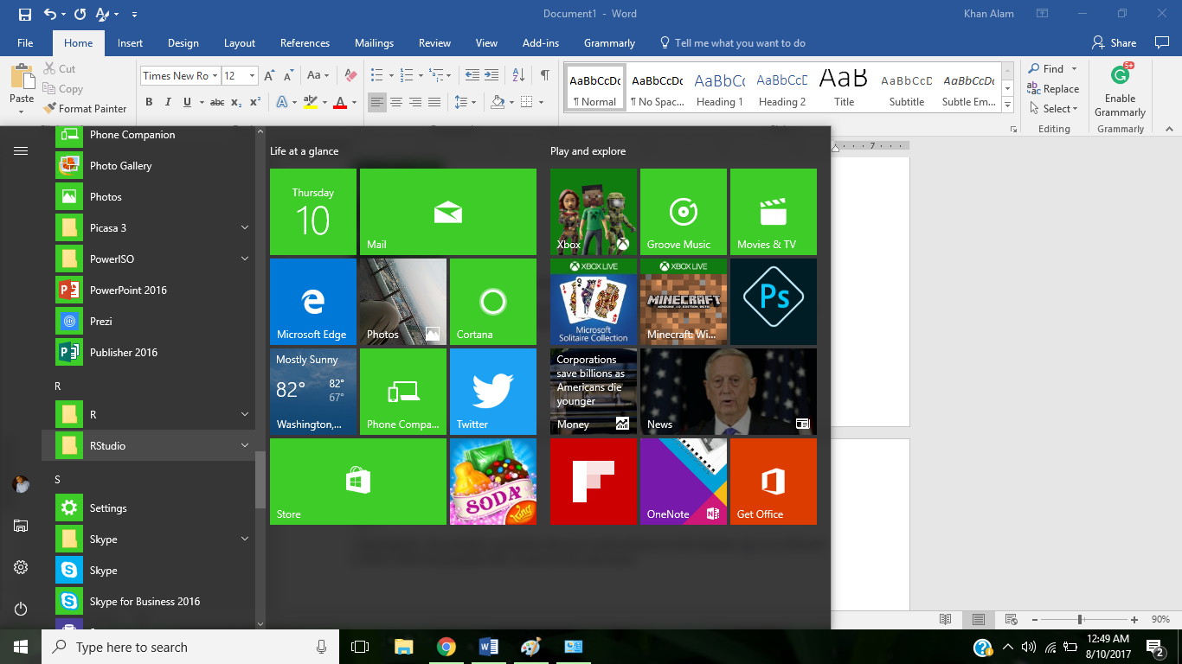
Or else, you can type R Studio in the search bar:
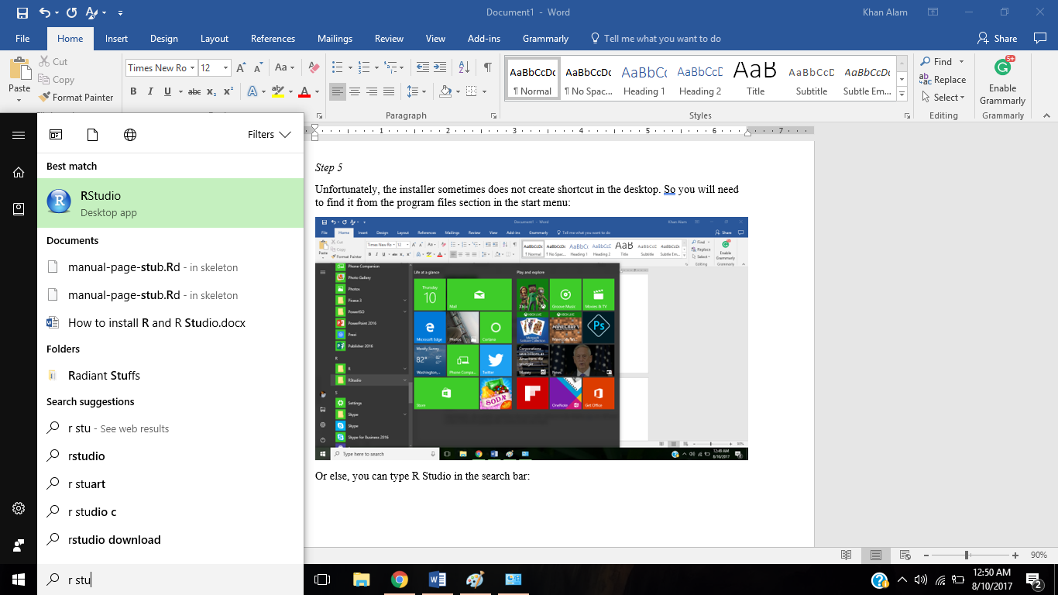

Step 6
Open R Studio by clicking on the icon. The software looks like this:
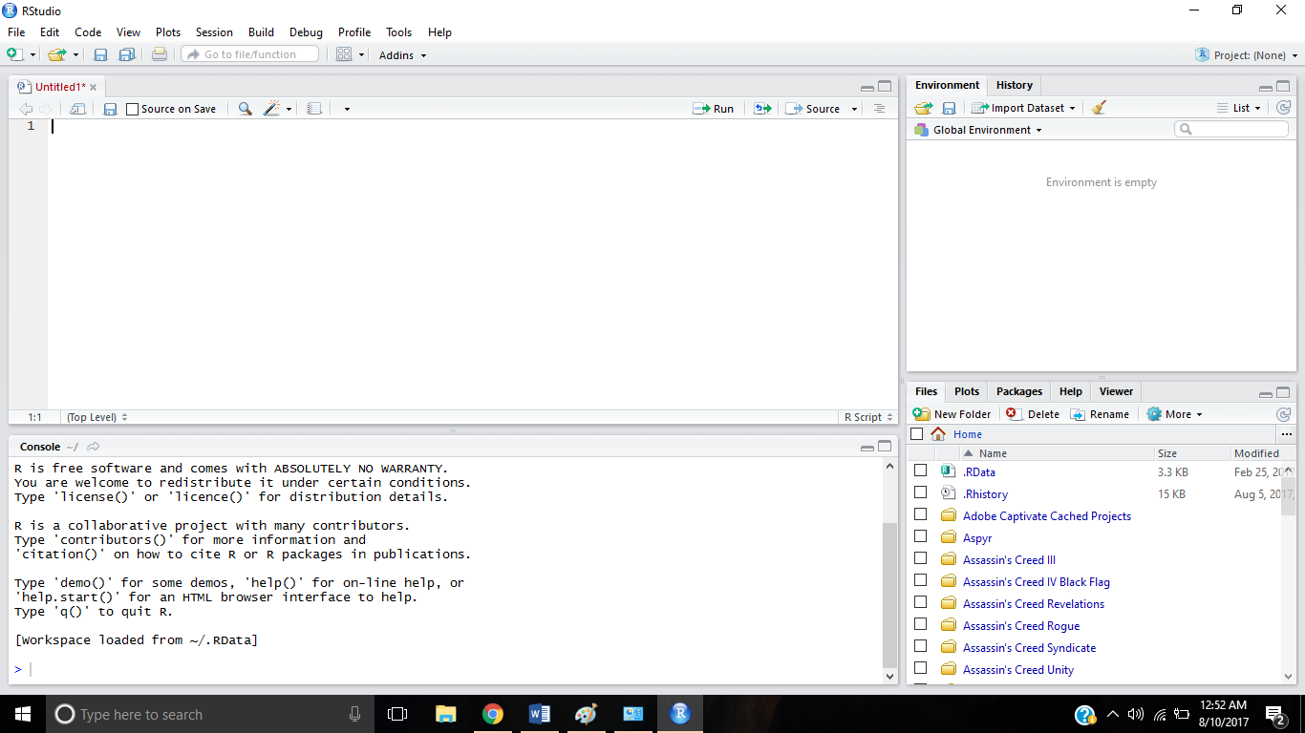

Installing RCmdr (R Commander)
Step 1
Open R Studio and you will see the above window.
In the console part of the software, copy and paste this code:
install.packages("Rcmdr", dependencies = TRUE)
The screen will look like this:
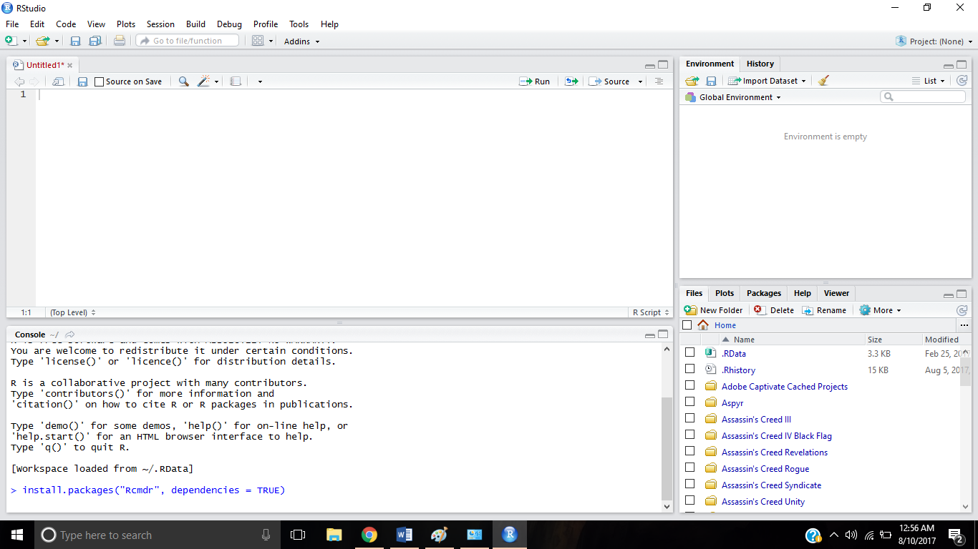
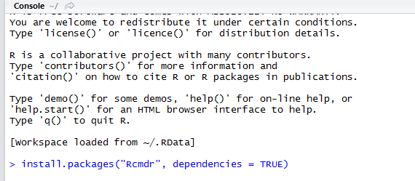
Then press enter. Please make sure you are connected to the internet all the time!!
The screen will look like the following:
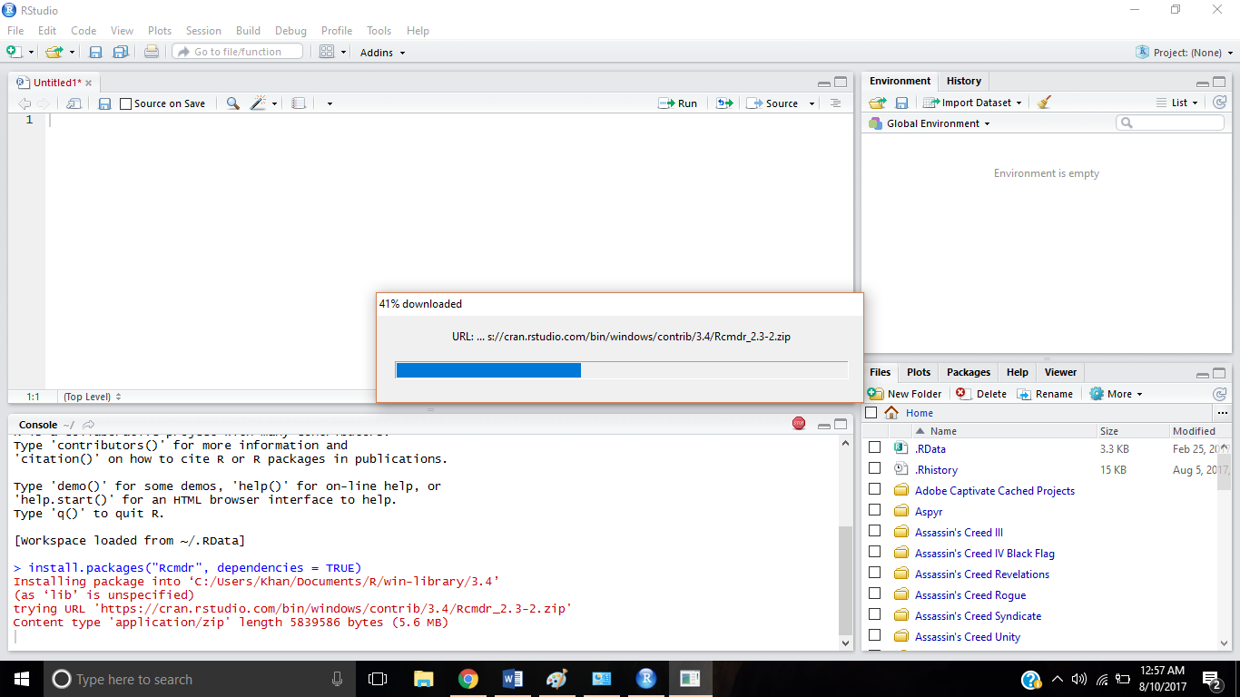
If the installation is successful, you will see the following screen:
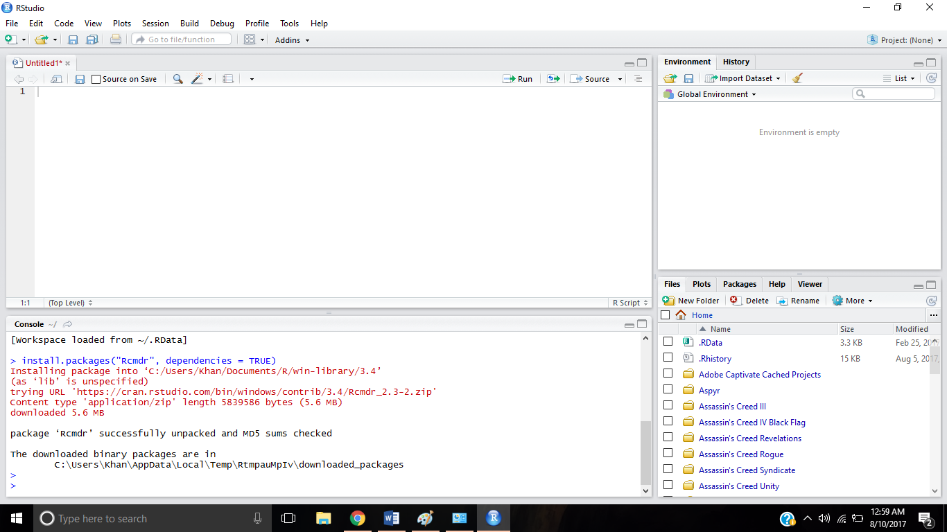

Finally, in the console, type:
library("Rcmdr")

This will open the interface called R Commander:
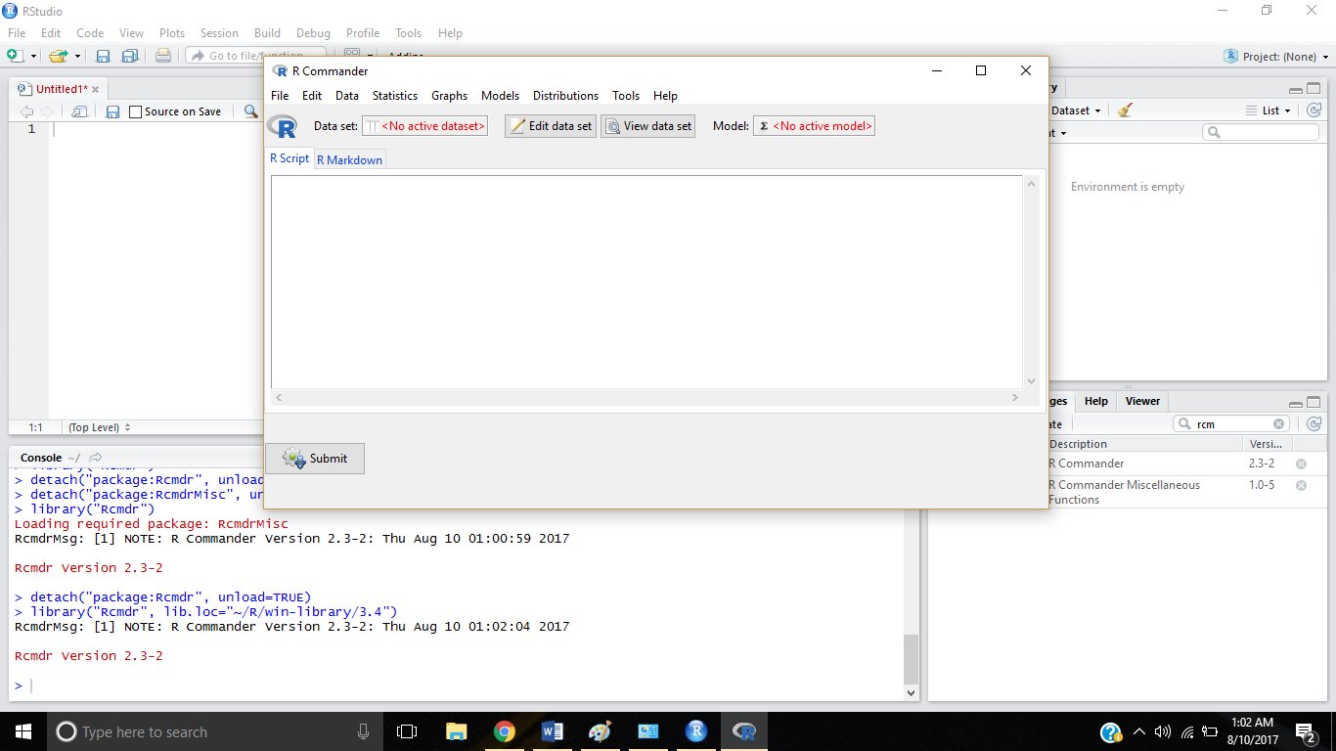

You are done and ready for your data analysis!!!

