FIN 470 – Mid Term 2
Time: 40 mins Marks – 20

(ii)
C
A
B
(i)
C
B
A
Price
Payoff

Q1. For the above two option payoff diagrams, list the number transaction you require to make the payoff combinations (3 + 3 = 6 marks)

The price of Apple Incorporated Stocks today is 116.7 USD. The data for the stock for last one month shows that the stock fluctuated with a variance of 32%². You have 2 call options of apple, the first maturing in 8 months and the second one maturing in 56 days. For the first call option, the Strike price is 116.7 USD. For the put option, the strike price is 100 USD. The opportunity cost of capital for owning an apple stock at the present market is 11% per annum, which also includes 4% premium of owning the apple stock.
Q2. For the call option, imagine that the apple stock can fluctuate once only in every four months. Then use this assumption to calculate the binomial valuation of the call option. (10 marks)
Q3. For the second call option, use the Black-Scholes formula to value the option. (4 marks)

Necessary Formulae
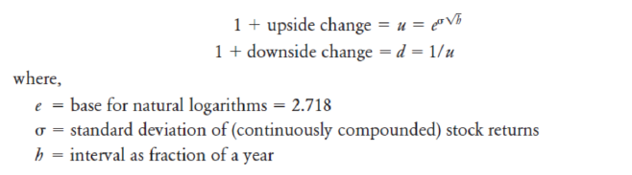
Binomial Method

Black Scholes Formula:
