Product Mix Problems:
Problem 1
Company A is trying to find out the product mix which will give it the maximum profit. It produces 6 products and the information for all of them is as follows:
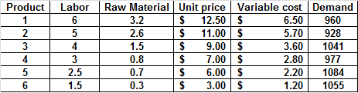
In order to solve this problem the following are the constraints:
1. Total labor used can not exceed 4500
2. Total raw material used can not exceed 1600
3. Production quantity can not exceed the demand quantity
4. Production of product can not be negative
Find out the solution using Excel solver.

Problem 2
